**Plasson**’s

Manufacturing Status Tracker

User Guide

# Features

* Manage manufacturing machines
* See only the machines with the desired status
* Configure available manufacturing statuses from a selection of 287 available statuses

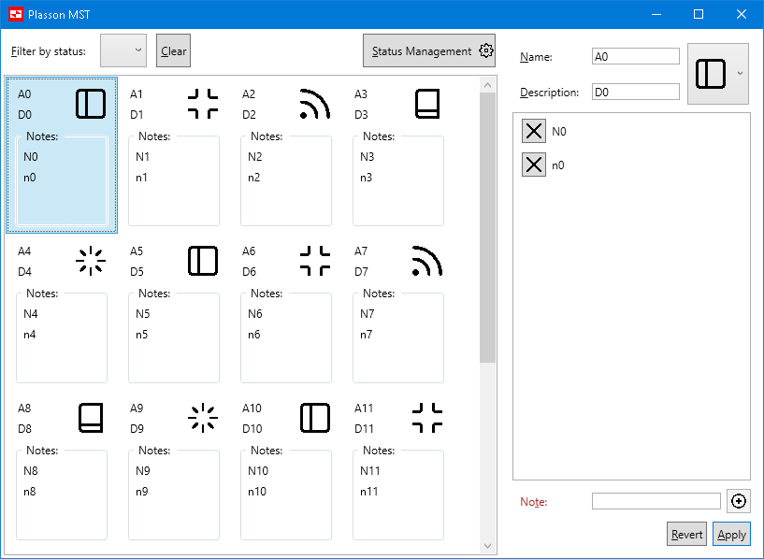

## Manufacturing machine configuration:

1. Select a machine from the list on the left and the machine data will populate the configuration panel on the right  
   Attempting to select different machine while there are unsaved changes in the current machine will cause a confirmation prompt.
2. Edit the machine name  
   Machine name must be non-empty and non-whitespace string
3. Edit the machine description
4. Select the desired status
5. Remove notes if desired by pressing on the X button next to it
6. Select a note in the notes list to populate the note text box with its value
7. Type a note in the note text box
8. Add the typed note to the list  
   Duplicate and whitespace notes are allowed; empty notes are not.
9. Revert or Apply the changes  
   Changes will take effect immediately after pressing either of those buttons.

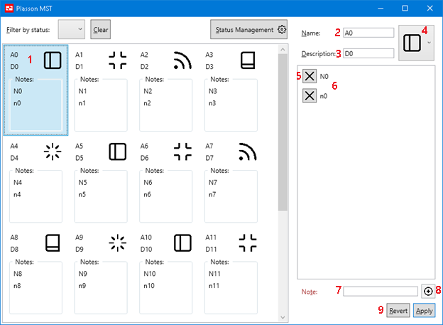

## Manufacturing machine statuses:

1. Select the desired status to filter by
2. Clear the filter in order to see all the machines
3. Open the status configuration screen

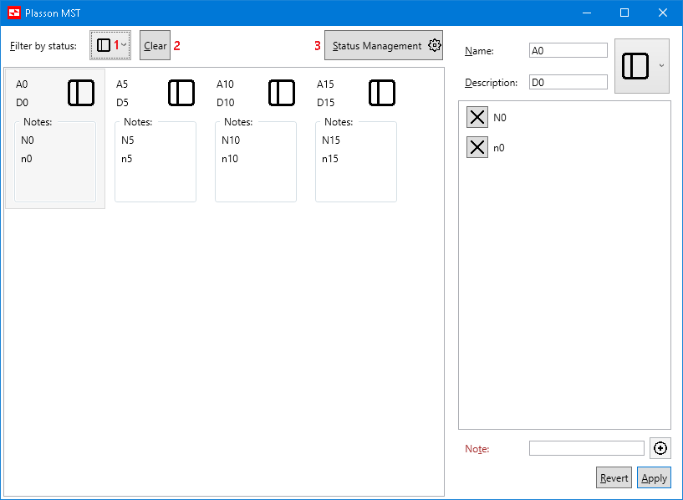

## Status management screen:

1. Select the desired status from the list on the left
2. Add the status to the available statuses on the right
3. Select one of the available statuses from the list on the right
4. Remove the available status  
   Statuses cannot be removed if they are being used by any machine.  
   In order to remove used statuses the user is expected to switch all relevant machines to a different status first.
5. Return to the main manufacturing machines tracker screen

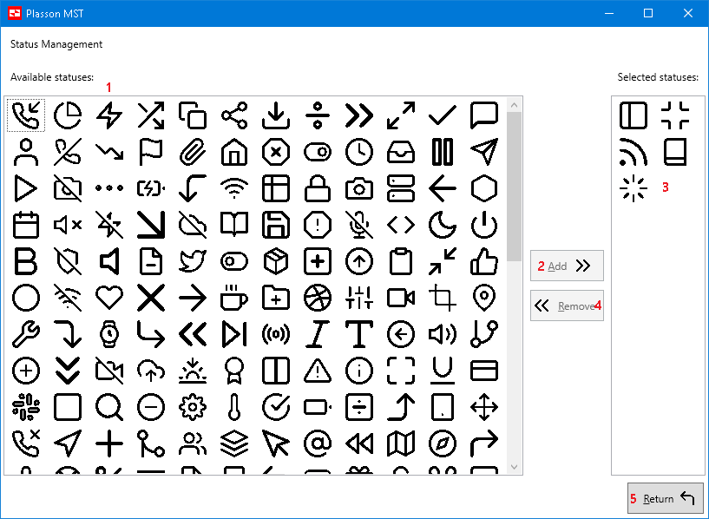

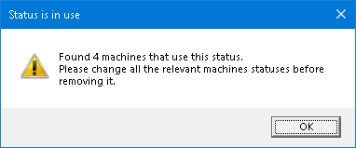

## Known issues and limitations

* Data is not saved between application runs

Real application will require DB usage to store the machines and statuses information

* Add\remove machines functionality was not implemented as it was not specified
* In real environment statuses will have a user-friendly string representation as well as the icon.  
  The status classes were designed with this in-mind but due to limited time it was decided that the statuses will be represented in the UI by the status icon alone.
* Status configuration applies the changes automatically.
* Machine configuration requires the user to manually apply the changes made to the machine.
* The icons list is not being virtualized which can cause performance issues.  
  In live product this list will be virtualized.
* There is a known binding-leak in IconResource from OperationalStatusModel which wasn’t addressed due to time constraints